Agent Based Simulation of Technological Innovation using Hypercycle Model
Yuanyuan Zhao ¹, Roland J. Ortt ², Bernhard R. Katzy ¹

¹Center for Technology Innovation and Management, Leiden Institute of Advanced Computer Science, Leiden University, Niels Bohrweg 1, 2333 CA Leiden, The Netherlands
²Delft Center for Entrepreneurship, Faculty of Technology, Policy and Management, Delft University of Technology, Jaffalaan 5, 2628 BX Delft, The Netherlands
Abstract
Technological innovation is agreed to be a driver of economic growth but the dynamics and uncertainty underlying technological development raise tough questions for policy-makers in terms of making strategies that can support technological innovation.The paper argues to base effective interventions for technological innovation on better understanding its dynamics and introduces agent based simulation as policy decision support system. A simulation model is developed and verified using the Nylon innovation case between 1926 and 1989. Second, the model is generalized for testing effects of alternative policy interventions. Simulation results show that Nylon innovation system is able to readjust itself to external shocks yet remain alive. Specifically, the intervention through changing resources has the most noticeable effect on the number of surviving hypercycles.
Key Words
Technological innovation system, system functions, agent based modelling, hypercycles model

Introduction
Technological innovation is agreed to be the drivers for economic growth (Dosi, 1982; Rycroft & Kash, 1994). But on the other hand the dynamics and uncertainty underlying technological development raise tough questions for policy-makers when crafting policies and strategies in support of technological innovation. Like Mowery and Rosenberg (2000) we assume that the understanding of the dynamics of technological innovation processes increases the chances for government intervention to be successful.
Technological innovation is a complex and dynamic process because it includes multiple different participants, such as individual entrepreneurs, companies, government, universities, financial institutions, consumers and other environmental factors. These actors and institutions interact and constitute technological innovation systems (TIS) (Bergek, Jacobsson, Carlsson, Lindmark, & Rickne, 2008). The complex interactions inside technological innovation systems give technological innovation nonlinear and dynamic process behaviour. This means that pre-defined plans and control, careful implementation, large budgets or large amounts of resources may not be a guarantee for success.
The recognition of this non-linear and dynamic behaviour of technological innovation brings new challenges to mainstream innovation research, which uses static research methods, e.g. statistic regression model based on patents data, publications data or innovation numbers. These static methods are unable to capture the dynamics underlying technological innovation process (Suurs & Hekkert, 2009; Zhao, Ortt, & Katzy, 2012) because they ignore the ordering of independent variables and have an emphasis on immediate causation only (Marshall Scott Poole, 2000).
Agent based modeling techniques, in contrast, capture dynamics and complexities that arise from the interactions inside systems that emerge from the behaviour of its member individuals (Garcia, 2005; Gilbert, Jager, Deffuant, & Adjali, 2007). It is a computational simulation tool belonging to the complexity theory field, which is based on defining behavioural rules for multiple agents. It complements and extends econometric approaches by incorporating interactions among system members, and adaptation in the system, revealing emergence result” (Schramm, Trainor, Shanker, & Hu, 2010). However, up to now, there is not much theorizing on the phenomena of emergence in economics or organizational science. Many scholars in the social science domain have tried to borrow theories from other disciplines such as physics, mathematics, and chemistry, in order to better understand the phenomenon of emergence. Padgett, for example, adopts the hypercycle theory, which explains the emergence of organic molecules from inorganic molecules in chemistry to explain the emergence of organizations and markets. From a hypercycle theory point of view, Padgett viewed economic production as artificial chemistry, which he explained that (Padgett, Lee, & Collier, 2003):
“Skills, like the chemical reactions, are rules that transform products into other products. Products, like chemicals, are transformed by skills. Firms, like organisms, are containers of skills that transform products. Trade, like food, passes transformed products around through exchange networks, renewing skills and thereby firms in the process. In the macroeconomic aggregate, product inputs flow into, and outputs flow out of, this trading network of firms and skills”(Page 2).
Although much simpler than any real social economic system, Padgett’s work succeeded in simulating the emergence of economic production systems with chains of action-reaction sequences that fold back on each other to keep themselves alive. . Just as chemical cycles are important for the emergence of life, the cycles of action-reaction sequences are crucial to economic growth, which means without them, any system itself will stop or die (Padgett et al., 2003).
Using the analogy of hypercycles, we model technological innovation as collective behaviour that emerges from micro-level interactions of agents´ activities. Such activities have been identified and classified into seven system functions of technological innovation systems by Hekkert, Suurs, Negro, Kuhlmann, and Smits (Hekkert, Suurs, Negro, Kuhlmann, & Smits, 2007) and will be introduced in section 2 of this paper. From these “atomic” functions “molecular chains” of complex system behaviour can be composed. These may start with any system function, add several others to finally add the same initial function again and repeat the pattern, which is called hypercycles in chemistry.
Recurring pattern, in innovation terms, determine the survivability of a technological innovation system. The purpose of such simulation is to understand the dynamics of technological innovation processes. In this way, it is expected to find the conditions that influence emergence of hypercycles and thereby support decision-making towards technology policies.
This paper is structured as follows: section 2 describes the research design; section 3 provides empirical verification of the simulation model with reference to the Nylon innovation case; section 4 goes one step further to explore more general application of the simulation model to anticipate the impact of alternative external interventions on the resilience of technical innovation systems. Section 5 concludes with preliminary findings and potential future studies.

2. Research design

2.1 Functions of technological innovation systems
The behaviour of agents in the simulation model is coded as system functions. All agent activities that contribute to the generation and diffusion of innovations are called system functions (Bergek, 2002). Hekkert et al. (2007) classified seven system functions, as summarized in Table 1:
Functions of TIS | Explanations
F1: Entrepreneurial activities | Entrepreneurial activities are those with entrepreneurial orientation characterized as risk-taking, innovative and proactive (Miller, 1983).
F2: Knowledge development | The development and accumulation of technical knowledge with no direct commercial orientation.
F3: Knowledge diffusion | Information communication through formal and informal networks.
F4: Guidance of the search | This function reflects a constraint factor which facilitates a convergence in technological development.
F5: Market formation | Technological innovation involves the creation of (niche) market to realize the commercialization of technical invention.
F6: Resource mobilization | This function is related to events which could change the resource base of TIS, including financial, material and human resource.
F7: Support from advocacy coalitions | In order to acquire legitimation, actors need to lobby politically to convince potential partners of the viability of the new technology.
Table 1 The seven system functions (Hekkert et al., 2007; Zhao, Ortt, & Katzy, 2013)

2.2 Empirical data
We use empirical data from the Nylon innovation case in order to verify the simulation model. The empirical data is provided by the case of Nylon innovation, which has been qualitatively analysed in our previous study (Zhao et al., 2013). We did code the history of the Nylon case between 1926 and 1989 with the seven system functions. We used co-coding approaches and expect that such “stylized facts” of Nylon technological innovations can be reproduced using the agent based model.

3. Empirical validation
Simulation models need be calibrated to describe reality. Empirical validation is a first test to test how much a simulation reproduces real world phenomena. We use the well documented historical case of the Nylon innovation process between 1935 and 2010. Members of the technological innovation systems and their behaviour are described in model terms. Validation of the model is carried out through comparing simulation outputs with the macro-level evolution of Nylon innovation.
The simulation presented here is programmed using open software NetLogo (Wilensky, 1999). The simulation codes is established based on a modification of Watts and Binder (2012)’s model by specifying agent’s rules using Nylon empirics. Time is modelled as 5000 time / simulation intervals so that 7 time ticks roughly equal 1 month.

3.1 Simulation results
The Nylon innovation was initiated by a strategic change of DuPont and therefore is modelled as a top-down reorientation triggered innovation mode. The origin of the innovation is set as system function “guidance triggered”. Further the Nylon innovation is represented in the simulation model by setting the rule transitions according to the empirical analysis of how Nylon innovation evolved over time.
Hypercycles did emerge. Their evolution is shown in Figure 1. The Y-axes shows the number of hypercycle starting from each of the seven system function. Different lines in this graph correspond to hypercyles with different start system functions: “Cycle 1” refers to hypercycles starting from system function 1, “Cycle2” to that from system function 2, and so on. All lines show a declining trend of hypercycles converging to 0 hypercycles in the system. Since hypercylce means that the system is able to self-sustain without external interventions, 0 hypercyle in Nylon TIS implies the system fails to realize self-organization and interventions or triggers from outside the system are needed in order to sustain its development. And the declining number of hypercycles in Nylon TIS means declining innovation degree. This is generally consistent with technical innovation systems that “run dead” without external stimulus and intervention. It is consistent with Nylon’s situation in that in the late phase Nylon encountered a financial crisis caused by world-wide oil shortages, leading to a panic to DuPont and reconsideration of the application research strategy.

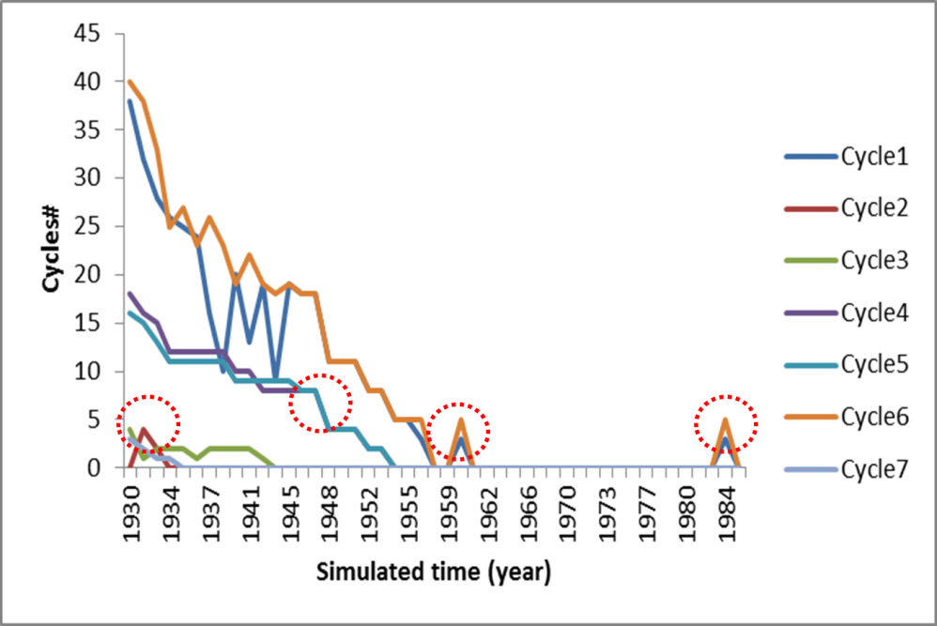
Figure 1 Evolution of hypercycles in Nylon case

3.2 Comparison
This section analyses whether the “stylized facts” of Nylon technological innovations have been reproduced in the simulation outputs. A careful look at Figure 1 finds that the turning points, marked in dotted circles, correspond to key events in Nylon’s innovation process. The following make a comparison between these evidences:
- Cycle1 and Cycle6, representing entrepreneurial activities and resource mobilization activities, surpass other cycles and dominate the innovation process, which can be illustrated by the top two lines in Figure 1. In the simulation, between the year 1960 and 1985, there are two peaks. These two peaks may correspond to the early 1970s in Nylon case, when Nylon was shocked by two world-wide oil crisis, Particularly in the simulated year 1960 the system has no hypercycle for the first time, which implies that the system is unable to maintain a self-organizing status. This unstable status is broken by the appearance of Cycle1 and Cycle6 in 1961, roughly corresponding to the first world oil shortage time, after which the system goes back to unstable status with no hypercycles until the re-appearance of Cycle1 and Cycle6 in 1984 in the simulation, approximately corresponding to the second world oil shortage crisis in Nylon case, after which the system has no hypercycle again. Although there are some discrepancy between the simulated time and the real time in Nylon case, it is important that this fluctuation pattern of the hypercycles is close to Nylon’s decline phase which is characterized by two times of crises caused by oil shortage and the following remedy activities by DuPont through re-starting applied research in Nylon (F1) and resource recombination (F6).
- Cycle2 and Cycle3 represent technological development activities. They appear at the beginning of the simulation in simulated year 1931. In the simulation as in the real case technological activities mainly happened in the early stage of Nylon innovation. This is consistent with the real situation that since 1936 the attention of Nylon innovation was put on market developing in terms of toothbrushes, stockings as well as military uses.
- Cyce4 and Cycle5, respectively representing the guidance and market formation activities, follow the same evolution line since the simulated year 1946 and disappear at the simulated year 1953. This is also roughly consistent with the influence of the Second World War on Nylon innovation. Shortly after the technological improvement phase of Nylon innovation, the second world war broke out which made niche market for Nylon technology. During the WWII, the main motor is government supported projects, government procurement, and military demand. The directions and guidance from national government (system function F4) also contribute to Nylon’s market formation (system function F5), which is represented as the strong overlap of the line of Cycle4 and Cylce5 in Figure 3.
- Cycle7, representing the lobbying activities in Nylon innovation, appears only at the beginning of the system. This means the activities of lobbying only happened in the beginning of Nylon innovation, which is consistent with the beginning of Nylon innovation in that Charles Stine, the director of DuPont submitted a proposal to DuPont’s executive committee to persuade them support fundamental research.
All the above corresponding points between the simulation outputs and Nylon innovation reality can be visualized in Figure 4, where three developmental phases correspond with the simulation results. The turning points of the graphs are interpreted with corresponding key events. What needs to be emphasized is that the there are some discrepancy between the simulated time and the real time in Nylon case but they are acceptable when taking systematic error into account. but the most important thing is that the fluctuation patterns of these graphs pretty well reproduce Nylon innovation realities.

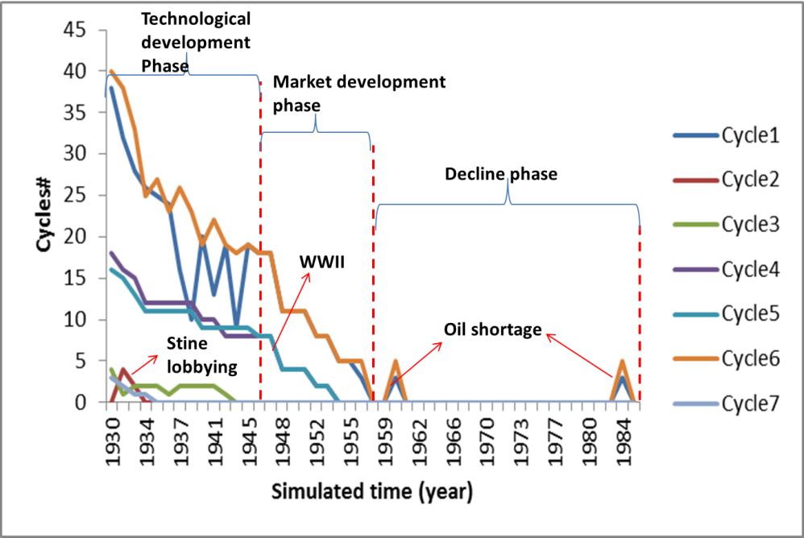
Figure 2 Simulation result and Nylon innovation reality

4. From verification to policy design
External shocks play a significant role in the Nylon innovation trajectory. We marked in dotted red circle in Figure 3 the second world war, and the two world-wild oil shortages,. In this section, we go one step further from reproducing historical facts to decision support, which means making predictions about aspects of the future. Similar to Watts and Binder (Watts & Binder, 2012) our analytic focus here is resilience of the technical innovation system to policy interventions or other external shocks. In order to do this, in section 4.1 we define shocks to the system, and then in section 4.2 we analyse system resilience by comparing how the final system status differs from that prior to the shock.

4.1 Shocks and policy interventions
Shocks stimulate the technological innovation system to react, which becomes visible as an increasing amount of system activities in each system function:
- Shocks on F1: changes in the amount of activities with entrepreneurial orientation characterized as risk-taking, innovative and proactive (Miller, 1983).
- Shocks on F2: primary scientists or researchers leave or participate in a technological innovation.
- Shocks on F3: changed in networks which are the channels for information communication.
- Shocks on F4: changes in terms of political regulations or strategic directions
- Shocks on F5: interventions via changing market demand through for example providing subsidies, decreasing taxes, or public project.
- Shocks on F6: changes in resources availability.
- Shocks on F7: the lobbying activities of entrepreneurs in order to persuade others to accept the particular technologies.

4.2 System resilience to external shocks
Figure 3 presents a particular example run of how the Nylon innovation system responses to external shocks. The Y-axis refers to the total number of hypercycles in each simulation. The pink line is a basic line which represents how system evolves when there is no shock. The other seven lines represent shocks to corresponding activities. Before the shocking time, which was set at simulation time 1500, all of the lines overlap each other. After being shocked, the system presents different resilience to different shocks, with shocks on F6, namely shocks through changing the resources, bringing the most significant influence on the emergence of hypercycles. Particularly, there are loss of hypercyles while shocking on F2，F4 and F7, namely changing the instances of knowledge development, guidance of the search, and searching for alliance activities respectively; shocks on F6, namely intervention through manipulating resources, significantly increase the existing hypercycles by the end of the simulation, as illustrated by the brown line in Figure 3; and there are slight changes on the number of surviving hypercycles when shocks are put on F1, F3 and F5, namely intervention through changing entrepreneurial activities, knowledge diffusion and market formation activities. It is obvious that each shock on system functions has a noticeable effect on the innovation system, however after each shock the system is still alive with surviving hypercycles. In this sense, the Nylon innovation system present a high resilience to external shocks and the system is able to readjust itself to the shocks over time. It is interesting to point out that the intervention through changing the resources has the most significant impact on Nylon innovation. One explanation could be the top-down reorientation nature of Nylon innovation, where innovation is initiated, planned and guided by DuPont’s top-down direction through the manipulation and re-combination of existing resources.

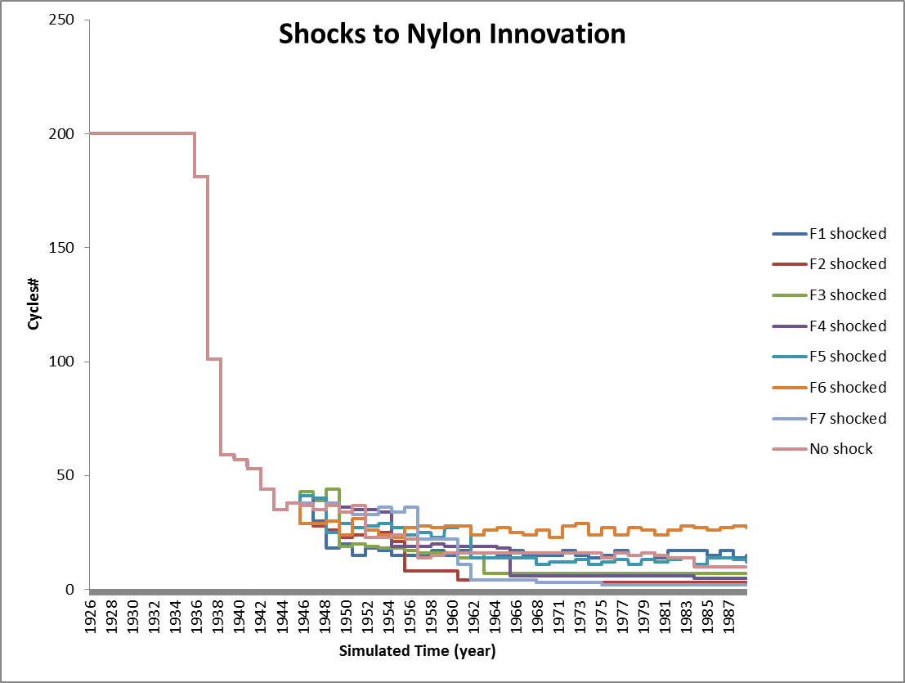
Figure 3 System resilience to external shocks

5. Conclusions and future study
This paper demonstrates an agent based model of technological innovation system with the purpose of better understanding the technological innovation dynamics and thereby providing policy support for policy designs. After empirical verification of the simulation model with the Nylon innovation case, experimental tests are designed to examine the resilience of innovation systems to external shocks. Simulation results discovered that Nylon innovation presents highly resilient to external shocks, with several hypercycles surviving the entire simulation process. Specifically, interventions through changing the resource allocation activities have the most significant influence on the innovation system.
The contributions of this paper are threefold. First it contributes to the adoption of one of the rare models for emergence, which has been developed in artificial chemistry to technological innovation cases. In this way, it helps generalizing the hypercycle theory.
Second, the study produces arguments that agent based modelling contributes a promising decision support method in complex interactions in technical innovation systems. Especially it helps transforming purely qualitative argumentations into quantitative analysis to conceive novel explanations for complex phenomena of technological innovations, as well as to better understanding of technological innovation dynamics.
Third the simulation model provides a useful tool for policy design in terms of anticipating and testing the effect of different policy interventions on technological innovations.
For future study, more empirical technological innovation cases are needed before a general agent based model of technological innovations can be generated. The timing of interventions may be integrated into the model since the intervention time to technological innovation has been acknowledged as an important factor. In addition, much remains to be done towards connecting the abstract model with empirical cases of technological innovations, and propose extensions to the basic model to allow different types of agents entering, and thereby connecting the diverse functions with the actors which perform them.
Acknowledgement
The authors would like to thank Dr Christopher J Watts for his valuable comments and help in agent based modelling as well as in the understanding of hypercycle theory.

References:
Bergek, A. 2002. Shaping and exploiting technological opportunities: The case of renewable energy technology in Sweden. Chalmers University of Technology, Goteborg.
Bergek, A., Jacobsson, S., Carlsson, B., Lindmark, S., & Rickne, A. 2008. Analyzing the functional dynamics of technological innovation systems: A scheme of analysis. Research Policy, 37(3): 407-429.
Dosi, G. 1982. TECHNOLOGICAL PARADIGMS AND TECHNOLOGICAL TRAJECTORIES - A SUGGESTED INTERPRETATION OF THE DETERMINANTS AND DIRECTIONS OF TECHNICAL CHANGE. Research Policy, 11(3): 147-162.
Garcia, R. 2005. Uses of agent-based modeling in innovation/new product development research. Journal of Product Innovation Management, 22(5): 380-398.
Gilbert, N., Jager, W., Deffuant, G., & Adjali, I. 2007. Complexities in markets: Introduction to the special issue. Journal of Business Research, 60(8): 813-815.
Hekkert, M. P., Suurs, R. A. A., Negro, S. O., Kuhlmann, S., & Smits, R. E. H. M. 2007. Functions of innovation systems: A new approach for analysing technological change. Technological Forecasting and Social Change, 74(4): 413-432.
Marshall Scott Poole, A. H. V. d. V., Kevin Dooley, Michael E. Holmes. 2000. Organizational Change and Innovation Processes: Theory and Methods for Research: Oxford University Press, USA.
Miller, D. 1983. The correlates of entrepreneurship in three types of firms. Management Science, 28: 770-791.
Mowery, D., & Rosenberg, N. 2000. The influence of market demand upon innovation: a critical review of some recent empirical studies. In B. R. Martin, & P. Nightingale (Eds.), The Political Economy of Science, Technology, and Innovation. UK: Edward Elgar Publishing Limited.
Padgett, J. F., Lee, D., & Collier, N. 2003. Economic production as chemistry. Industrial and Corporate Change, 12(4): 843-877.
Rycroft, R. W., & Kash, D. E. 1994. Technology policy in a complex world. Technology in Society, 16(3): 243-267.
Schramm, M. E., Trainor, K. J., Shanker, M., & Hu, M. Y. 2010. An agent-based diffusion model with consumer and brand agents. Decision Support Systems, 50(1): 234-242.
Suurs, R. A. A., & Hekkert, M. P. 2009. Cumulative causation in the formation of a technological innovation system: The case of biofuels in the Netherlands. Technological Forecasting and Social Change, 76(8): 1003-1020.
Watts, C., & Binder, C. R. 2012. simulating shocks with the hypercycles model of economic production. Paper presented at the International Congress on Environmental Modelling and Software (iEMSs), Leipzig Germany.
Wilensky, U. 1999. Netlogo. Center for Connected Learning and Computer-Based Modeling: Northwestern University.
Zhao, Y., Ortt, J. R., & Katzy, B. R. 2012. Innovation as a complex adaptive system behavior: Implications for innovation process research, International Association for Management of Technology. Taipei, Taiwan.
Zhao, Y., Ortt, R., & Katzy, B. 2013. A Complexity Approach to Technological Innovation—the case of Nylon.

Corresponding author: Tel.: +31 659565037 Email address: yuanyuan.zhao@cetim.org

